1. 1. Question

Which service manages the sending out of alert email messages for Microsoft Intune?

* +  Office 365
  +  Microsoft Intune
  +  Azure Active Directory

Unattempted

<https://docs.microsoft.com/en-us/mem/intune/remote-actions/custom-notifications>

1. 2. Question

Which two of the following authentication methods does not depend on the availability of the on-premises infrastructure?

* +  Pass-through Authentication
  +  Active Directory Federation Services
  +  Password Hash Synchronization
  +  Cloud Identity

Unattempted

A cloud-only identity uses user accounts that exist only in Azure AD. Cloud identity is typically used by small organizations that do not have on-premises servers or do not use AD DS to manage local identities.  
Password hash synchronization is one of the sign-in methods used to accomplish a hybrid identity. Azure AD Connect synchronizes a hash, of the hash, of a user’s password from an on-premises Active Directory instance to a cloud-based Azure AD instance. You sign in to the service by using the same password you use to sign in to your on-premises Active Directory instance.

1. 3. Question

You are a compliance officer for your organization. You need to implement a policy to schedule the periodic verification of Azure Active Directory group memberships. Which tool will help you achieve this objective?

* +  Access Reviews
  +  Conditional Access
  +  Privileged authorization Management
  +  Privileged Identity Management

Unattempted

Azure Active Directory (Azure AD) access reviews enable organizations to efficiently manage group memberships, access to enterprise applications, and role assignments. User’s access can be reviewed on a regular basis to make sure only the right people have continued access.  
More Info:  
<https://docs.microsoft.com/en-us/azure/active-directory/governance/access-reviews-overview>

1. 4. Question

Identify two statements about OneDrive sharing controls

* +  They can be the same level of permissiveness as SharePoint sharing controls.
  +  They must be the same as the SharePoint sharing controls
  +  They can be more permissive than SharePoint sharing controls.
  +  They can be less permissive than SharePoint sharing controls.

Unattempted

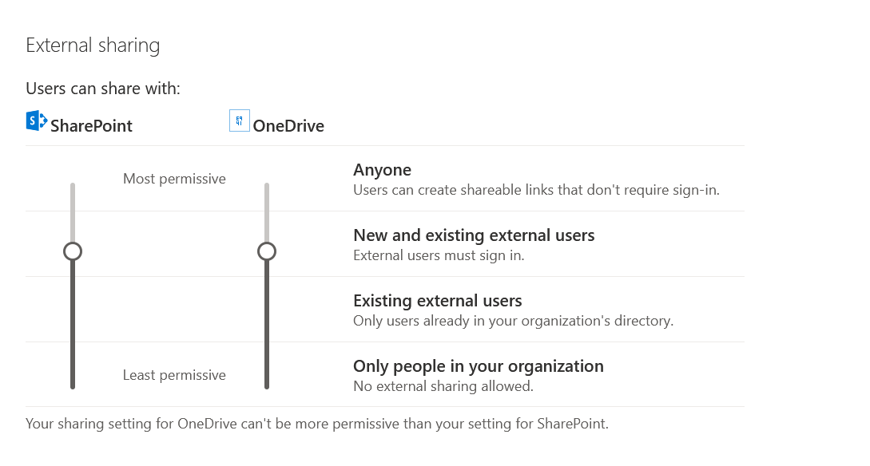

1. 5. Question

When authenticating a user under Azure MFA which three of the following are official concepts?

* +  Something a user knows
  +  Something a user does
  +  Something a user has
  +  Something a user is

Unattempted

Azure Multi-Factor Authentication works by requiring two or more of the following authentication methods:  
Something you know, typically a password.  
Something you have, such as a trusted device that is not easily duplicated, like a phone or hardware key.  
Something you are – biometrics like a fingerprint or face scan.

For detailed information please refer to the following link  
<https://docs.microsoft.com/en-us/azure/active-directory/authentication/concept-mfa-howitworks>

1. 6. Question

Which type of Microsoft Cloud App Security alert can be triggered by Cloud Discovery?

* +  New Location Alert
  +  New Admin Location alert
  +  New Admin User alert
  +  Newly Discovered Service alert

Unattempted

<https://docs.microsoft.com/en-us/cloud-app-security/cloud-discovery-policies>

1. 7. Question

You are a Microsoft 365 Administrator for your organization. As a part of the business initiative, you have been asked for both aggregate data and detailed dashboards of where your organization stands in relation to Microsoft 365 adoption. Which tools would be most helpful in providing this data?

* +  Power BI
  +  SharePoint Site Collection Reports
  +  Security and Compliance center audit logs
  +  Microsoft 365 Usage Analytics
  +  Azure audit logs
  +  Microsoft 365 Activity Reports

Unattempted

Use Microsoft 365 usage analytics within Power BI to gain insights on how your organization is adopting the various services within Microsoft 365 to communicate and collaborate  
You can easily see the activity reports to understand how people in your business are using Microsoft 365 services. For example, you can identify who is using a service a lot and reaching quotas, or who may not need a Microsoft 365 license at all.  
A combination of both these tools will reflect where your organization stands in relation to adopting Microsoft 365.

1. 8. Question

The_______________________________is a one-stop shop to manage and complete tasks for your mobile devices. This workspace includes the services used for device management, including Intune and Azure Active Directory, and to also manage client apps.

* +  Microsoft 365 admin center
  +  Microsoft Endpoint Manager admin center
  +  Security and compliance center
  +  Intune control panel

Unattempted

The Microsoft Endpoint Manager admin center is where you can find the Microsoft Intune service, as well as other device management related settings. Understanding the features available in Intune will help you accomplish various Mobile Device Management (MDM) and Mobile Application Management (MAM) tasks.  
<https://docs.microsoft.com/en-us/mem/intune/fundamentals/what-is-device-management>

1. 9. Question

Password change management recommends customers configure _________________ so that password changes in Azure are updated in the on-premises Active Directory

* +  Exchange hybrid write-back
  +  Password change management
  +  Password write-back
  +  Privileged Identity management

Unattempted

Password writeback is a feature of Azure AD Connect which ensures that when a password changes in Azure AD (password change, self-service password reset, or an administrative charge to a user password) it is written back to the local AD  if they meet the on-premises AD password policy.

1. 10. Question

Identify four types of Groups available with Microsoft 365.

* +  Security groups
  +  Domain local groups
  +  local groups
  +  Microsoft 365 groups
  +  Universal groups
  +  Distribution groups

Unattempted

In the Groups section of the Microsoft 365 admin center, you can create and manage these types of groups:  
Microsoft 365 groups (formerly Office 365 groups) are used for collaboration between users, both inside and outside your company.  
Distribution groups are used for sending notifications to a group of people.  
Security groups are used for granting access to resources such as SharePoint sites.  
Mail-enabled security groups are used for granting access to resources such as SharePoint and emailing notifications to those users.  
Shared mailboxes are used when multiple people need access to the same mailbox, such as company information or support email address.

More Info:  
<https://docs.microsoft.com/en-us/microsoft-365/admin/create-groups/compare-groups?view=o365-worldwide>

1. 11. Question

What data does MyAnalytics analyze?

* +  which information, within Office 365, is accessed most
  +  malware incidents in emails collated from Exchange data
  +  user log-in data collated from Azure Active Directory
  +  how users spend their time and with whom they spend it

Unattempted

MyAnalytics is a personalized dashboard that provides a summary of the hours one spends in meetings, using email, focusing, and working after hours, as well as suggestions on how to reduce unproductive meeting times and post-schedule work.  
In essence, it analyzes how users spend their time and with whom they spend it.

1. 12. Question

Identify two features or capabilities of the Secure Score?

* +  Track user security policies
  +  Provide configuration steps for security recommendations for links to configuration controls
  +  Recommend security configurations for the Microsoft 365 services
  +  Administer user risk policies

Unattempted

Microsoft Secure Score is a measurement of an organization’s security posture, with a higher number indicating more improvement actions taken. It can be found at https://security.microsoft.com/securescore in the Microsoft 365 security center.  
Secure Score helps organizations:  
Report on the current state of the organization’s security posture.  
Improve their security posture by providing discoverability, visibility, guidance, and control.  
Compare with benchmarks and establish key performance indicators (KPIs).  
More Info:  
<https://docs.microsoft.com/en-us/microsoft-365/security/mtp/microsoft-secure-score?view=o365-worldwide>

1. 13. Question

Which area of the admin center do you use to create Alerts?

* +  Setup
  +  Security & Compliance
  +  Settings
  +  Devices

Unattempted

To create an alert policy, open the Office 365 Admin Center, and click on the Security option. When the Security & Compliance screen appears, expand the Alerts section, and then click on Dashboard. This will cause Office 365 to a list of existing alert policies. To create a new alert policy, on the dashboard click on the New Alert Policy button, shown in below Figure

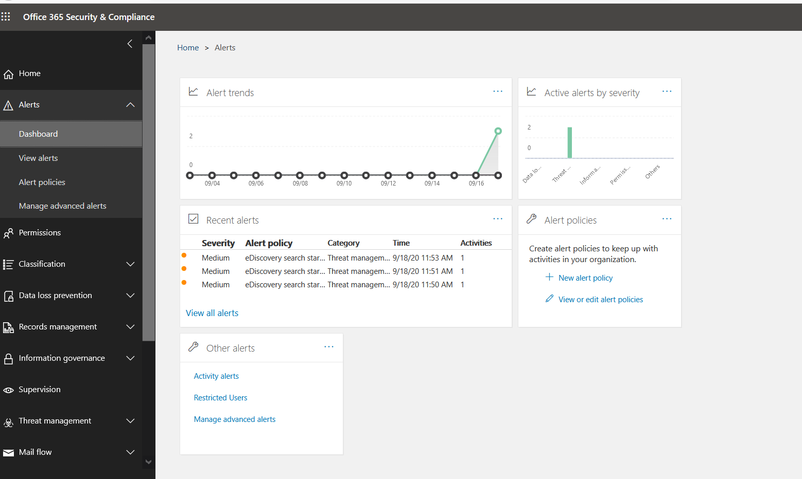

1. 14. Question

TRUE OR FALSE  
Microsoft Cloud App Security rates apps from 1 to 10. Low-risk apps are rated 10.

* +  FALSE
  +  TRUE

Unattempted

<https://docs.microsoft.com/en-us/cloud-app-security/risk-score>

1. 15. Question

Microsoft 365 Activity Reports are accessed through which interface?

* +  SharePoint Admin Centre
  +  Security & Compliance Centre
  +  Report Center
  +  Microsoft 365 Admin Centre

Unattempted

1. 16. Question

Which two of the listed methods allow you to configure authentication where password validation will happen on-premises.

* +  Active Directory federation services
  +  Cloud Identity
  +  Password Hash Synchronization
  +  Pass-through Authentication

Unattempted

AD FS provides simplified, secured identity federation and Web single sign-on (SSO) capabilities. Federation with Azure AD or O365 enables users to authenticate using on-premises credentials and access all resources in the cloud. As a result, it becomes important to have a highly available AD FS infrastructure to ensure access to resources both on-premises and in the cloud.  
Azure Active Directory (Azure AD) Pass-through Authentication allows your users to sign in to both on-premises and cloud-based applications using the same passwords. This feature provides your users with a better experience – one less password to remember and reduces IT helpdesk costs because your users are less likely to forget how to sign in.  
This feature is an alternative to Azure AD Password Hash Synchronization, which provides the same benefit of cloud authentication to organizations. However, certain organizations wanting to enforce their on-premises Active Directory security and password policies can choose to use Pass-through Authentication instead.

1. 17. Question

What kind of tool is PowerBI?

* +  a data archiving tool
  +  a data visualization tool
  +  an anti-malware tool
  +  a bulk data upload tool

Unattempted

Power BI is a collection of software services, apps, and connectors that work together to turn your unrelated sources of data into coherent, visually immersive, and interactive insights. Your data may be an Excel spreadsheet or a collection of cloud-based and on-premises hybrid data warehouses. Power BI lets you easily connect to your data sources, visualize and discover what’s important, and share that with anyone or everyone you want.  
Hence Power BI can be considered as a data visualization tool.

1. 18. Question

eDiscovery administrators can see

* +  All cases
  +  Only cases that they assigned to them

Unattempted

eDiscovery Administrator can:  
Access all cases that are listed on the eDiscovery and Advanced eDiscovery pages in the Security & Compliance Center.  
Access case data in Advanced eDiscovery for any case in the organization.  
Manage any eDiscovery case after they add themselves as a member of the case.  
<https://docs.microsoft.com/en-us/microsoft-365/compliance/assign-ediscovery-permissions?view=o365-worldwide>

1. 19. Question

What is the name of the tool that manages synchronization between Azure Active Directory and Active Directory Domain Services?

* +  Active Directory Connect
  +  Directory Connect
  +  Azure AD Connect
  +  AD Sync Connect

Unattempted

Azure AD Connect is the Microsoft tool designed to meet and accomplish your hybrid identity goals. It provides the following features:  
Password hash synchronization – A sign-in method that synchronizes a hash of a user’s on-premises AD password with Azure AD.  
Pass-through authentication – A sign-in method that allows users to use the same password on-premises and in the cloud, but doesn’t require the additional infrastructure of a federated environment.  
Federation integration – Federation is an optional part of Azure AD Connect and can be used to configure a hybrid environment using an on-premises AD FS infrastructure. It also provides AD FS management capabilities such as certificate renewal and additional AD FS server deployments.  
Synchronization – Responsible for creating users, groups, and other objects. As well as, making sure identity information for your on-premises users and groups is matching the cloud. This synchronization also includes password hashes.  
Health Monitoring – Azure AD Connect Health can provide robust monitoring and provide a central location in the Azure portal to view this activity.

1. 20. Question

What action do you need to complete to grant users the right to use an app?

* +  Assign the app to a user.
  +  Grant permissions in the app settings.
  +  Set app permissions to all users.

Unattempted

Prior to assigning the app to a user, you must create a user, create a group, and enroll a device.  
You can then use Intune to add and assign a client app to your company’s workforce/user. Remember one of the admin’s priorities is to ensure that end-users have access to the apps they need to do their work.

1. 21. Question

Which identifier is used to register devices with the Windows AutoPilot Deployment Service?

* +  Device IP address
  +  Device Hardware ID
  +  Device License number
  +  Company ID

Unattempted

Before deploying a device using Windows Autopilot, the device must be registered with the Windows Autopilot deployment service. Ideally, this registration is performed by the OEM, reseller, or distributor from which the devices were purchased. The device hardware ID is required as an identifier in such a case to simplify the concept. In reality, the process is more complex and has been explained in below link  
[https://docs.microsoft.com/en-us/mem/autopilot/add-devices](https://docs.microsoft.com/en-us/mem/autopilot/add-devices%C2%A0)

1. 22. Question

Identify two features of Intune Mobile Application Management.

* +  Wipe managed application profile
  +  Wipe managed device
  +  Define application-based security policies
  +  Require device PIN

Unattempted

As an IT admin, you can use Microsoft Intune to manage the client apps that your company’s workforce uses. This functionality is in addition to managing devices and protecting data.  
Require device PIN and Wipe managed device are features of MDM.  
More Info:  
<https://docs.microsoft.com/en-us/mem/intune/apps/app-management>

1. 23. Question

You are an IT administrator for a company. You have been asked to configure an authentication method where users are authenticated on-premises.  Which option would suit best to achieve this objective?

* +  Cloud Identity
  +  Enterprise Mobility +Security
  +  Password hash synchronization
  +  Active Directory Federation Services

Unattempted

AD FS provides simplified, secured identity federation and Web single sign-on (SSO) capabilities. Federation with Azure AD or O365 enables users to authenticate using on-premises credentials and access all resources in the cloud. As a result, it becomes important to have a highly available AD FS infrastructure to ensure access to resources both on-premises and in the cloud.

1. 24. Question

In order to connect Microsoft 365 Usage Analytics to Power BI, what data must you provide?

* +  Global Administrator Object ID
  +  Tenant ID
  +  Activity Report ID
  +  Power BI template ID

Unattempted

1. 25. Question

Unmanned devices, such as kiosks and digital signs need, to be assigned a license.

* +  FALSE
  +  TRUE

Unattempted

<https://docs.microsoft.com/en-us/deployoffice/device-based-licensing>

1. 26. Question

Within Compliance Manager, which tool can be used to manage documents for legal cases?

* +  Service Assurance
  +  Compliance Workflows
  +  Data Subject Requests
  +  eDiscovery

Unattempted

Electronic discovery, or eDiscovery, is the process of identifying and delivering electronic information that can be used as evidence in legal cases. You can use eDiscovery tools in Microsoft 365 to search for content in Exchange Online mailboxes, Microsoft 365 Groups, Microsoft Teams, SharePoint Online and OneDrive for Business sites, and Skype for Business conversations, and Yammer teams.  
More information:  
<https://docs.microsoft.com/en-us/microsoft-365/compliance/ediscovery?view=o365-worldwide>

1. 27. Question

Windows AutoPilot can be used with which operating system?

* +  iOS
  +  Windows 10
  +  Windows 8.0 or later
  +  Android

Unattempted

Windows AutoPilot applies to Windows 10 only.  
More Info:  
<https://docs.microsoft.com/en-us/mem/autopilot/windows-autopilot>

1. 28. Question

When deploying Azure Active Directory Connect Password Hash synchronization, what happens to the Azure AD Password Policy?

* +  Organizations must choose  which password policy controls to deploy
  +  Nothing
  +  The on-premises Active Directory password control settings are synchronized to Azure AD
  +  The Azure AD password policy wins

Unattempted

Password hash synchronization is one of the sign-in methods used to accomplish a hybrid identity. Azure AD Connect synchronizes a hash, of the hash, of a user’s password from an on-premises Active Directory instance to a cloud-based Azure AD instance.  
When password hash synchronization is enabled, the password complexity policies in your on-premises Active Directory instance override complexity policies in the cloud for synchronized users. You can use all of the valid passwords from your on-premises Active Directory instance to access Azure AD services.  
More Info:  
<https://docs.microsoft.com/en-us/azure/active-directory/hybrid/how-to-connect-password-hash-synchronization>

1. 29. Question

When using Microsoft Intune, apps can be protected by using which policies?

* +  App protection policies
  +  App security policies
  +  App checking policies
  +  App configuration policies

Unattempted

App protection policies (APP) are rules that ensure an organization’s data remains safe or contained in a managed app

1. 30. Question

The cost of a Microsoft 365 subscription will depend on the SKU purchased and any add-in services purchased. Which other factor affects the cost?

* +  country location
  +  discount negotiated
  +  number of users
  +  support level purchased

Unattempted

The total cost of Microsoft 365 subscription for an organization will depend on the SKU’s purchased, any add-in services purchased & the number of users.

1. 31. Question

Self-Service password reset can update on-premise and cloud passwords?

* +  TRUE
  +  FALSE

Unattempted

Azure Active Directory (Azure AD) self-service password reset (SSPR) gives users the ability to change or reset their password, with no administrator or help desk involvement. If a user’s account is locked or they forget their password, they can follow prompts to unblock themselves and get back to work.  
Password reset is subject to conditions or requirements configured(e.g. security questions) by administrators. After successful validation, user passwords can also be written back to an on-premise identity AD environment.

1. 32. Question

The general SLA for Microsoft 365 availability is expressed as

* +  99.90%
  +  100%
  +  99%
  +  99.99%

Unattempted

<https://tomtalks.blog/2020/02/what-is-the-microsoft-teams-service-level-agreement-99-9-uptime/>

1. 33. Question

Organizations can choose Microsoft GCC if they meet this requirement?

* +  Public sector organization
  +  Private sector organization
  +  Educational Institute

Unattempted

To meet the unique and evolving requirements of the United States Federal, State, Local, and Tribal governments, as well as contractors holding or processing data on behalf of the US Government, Microsoft offers Office 365 US Government Community (GCC) services. Available through multiple channels including Volume Licensing, interested organizations go through a validation process to ensure eligibility before an environment is established. Trials are available to only US Government entities at this time.

1. 34. Question

The feature that allows just-in-time rights management and access rights elevation is which of the following?

* +  Baseline Security Policies
  +  Conditional Access
  +  Privileged Identity Management
  +  Security defaults
  +  Access Reviews

Unattempted

Just-in-Time Privileged Access Management (JIT PAM) is the method by which organizations can enforce true least privilege, to drastically reduce the threat surface.  
Privileged Identity Management provides time-based and approval-based role activation to mitigate the risks of excessive, unnecessary, or misused access permissions on resources that you care about. Here are some of the key features of Privileged Identity Management:  
Provide just-in-time privileged access to Azure AD and Azure resources  
Assign time-bound access to resources using start and end dates  
Require approval to activate privileged roles  
Enforce multi-factor authentication to activate any role  
Use justification to understand why users activate  
Get notifications when privileged roles are activated  
Conduct access reviews to ensure users still need roles  
Download audit history for internal or external audit

1. 35. Question

Office 365 Attack Simulator is a part of __________________________.

* +  AAD Premium Plan 1
  +  AAD Premium Plan2
  +  Office 365 Advanced Threat Protection Plan 1
  +  Office 365 Advanced Threat Protection Plan 2

Unattempted

If your organization has Office 365 Advanced Threat Protection (ATP) Plan 2, which includes Threat Investigation and Response capabilities, you can use Attack Simulator in the Security & Compliance Center to run realistic attack scenarios in your organization. These simulated attacks can help you identify and find vulnerable users before a real attack impacts your bottom line.

1. 36. Question

You are a security administrator for ABC company. ABC Company’s CIO has asked you to automate a process to check on group memberships and remove stale accounts from groups. Which tool or feature would you use to fulfill the requirement?

* +  Baseline Security Policies
  +  Privileged Identity Management
  +  Security Defaults
  +  Access Reviews
  +  Conditional Access

Unattempted

Access reviews allow organizations to recommend and automate permissions or group management, such as removing users from groups after periods of inactivity.  
More Info  
<https://docs.microsoft.com/en-us/azure/active-directory/governance/access-reviews-overview>

1. 37. Question

You are a security auditor with ABC company. You discover that several users in your organization are using passwords which can be considered poor as they contain the name of your company. Which tool/feature would you use to prevent users from choosing passwords that contain specific words?

* +  Self-service password reset
  +  Baseline security policies
  +  Security defaults
  +  Custom banned password list

Unattempted

Administrators can configure a list of banned passwords that shouldn’t be allowed in their organization through feature known as “Custom banned password list”. This configuration can also be extended to on-premise AD deployment.  
For more information  
<https://docs.microsoft.com/en-us/azure/active-directory/authentication/concept-password-ban-bad>

1. 38. Question

What are the two characteristics of the public cloud? Each correct answer presents a complete solution.

* +  NOTE: Each correct selection is worth one point.
  +  dedicated hardware
  +  metered pricing
  +  unsecured connections
  +  self-service management
  +    limited storage

Unattempted

Cloud does provide (D) metered pricing, as you pay for the resources you use. IT also provides a self-managed service, as you can use the portal to add, change, and also remove the resources you need when you need them. Hardware is shared among public cloud clients, so it is NOT dedicated. Connections on the cloud are SECURED, so it (unsecured connections) does not apply to Public Cloud. Storage is virtually unlimited on the cloud, so “limited storage” does not apply either.

1. 39. Question

You are a network administrator for ABC company. The CIO of ABC company has asked you to provide remote access to internal applications securely using existing AAD Conditional Access policies. Which tool would you use to achieve the objective?

* +  Azure Remote Applications
  +  Azure Reverse proxy
  +  Azure Proxy Authentication Service
  +  Azure application proxy

Unattempted

When the need arises to securely provide access for internal line-of-business apps to people outside your network Azure Application Proxy can be used to achieve this goal. It is a great alternative to VPN’s (Virtual Private Network) which needs complicated VPN tunnel configuration.  
One added benefit is that applications configured to use Azure Application Proxy can also take advantage of Azure MFA.

1. 40. Question

This question requires that you evaluate the “Italicized” text to determine if it is correct.

An organization that hosts its infrastructure in a private cloud can decommission its data center.

Instructions: Review the” Italicized” text. If it makes the statement correct, select “No change is needed”. If the statement is incorrect, select the answer choice that makes the statement correct.

* +  No change is needed
  +  On Hyper V host
  +  in the public cloud
  +  In a hybrid cloud

Unattempted

The only alternative that makes it possible for the company, to shut down its servers is to be 100% hosted on the cloud, specifically is the public cloud

1. 41. Question

Identify 3 best practices for determining the licensing strategy for your organization.

* +  Sign a non-disclosure agreement
  +  Define user profiles or personas
  +  Define service and feature requirements
  +  Plan for the baseline

Unattempted

Determining and implementing the best strategy includes:  
Define baseline  
Define service requirements  
Define personas  
Consider add ons

1. 42. Question

You are an IT director for a medium-sized commercial organization with 220 employees. You have to decide on a cost-effective solution from Microsoft 365 services range for your users. Which option out of the following would be the best choice?

* +  Microsoft 365 Business
  +  Microsoft 365 E3
  +  Microsoft 365 G3
  +  Microsoft 365 E5

Unattempted

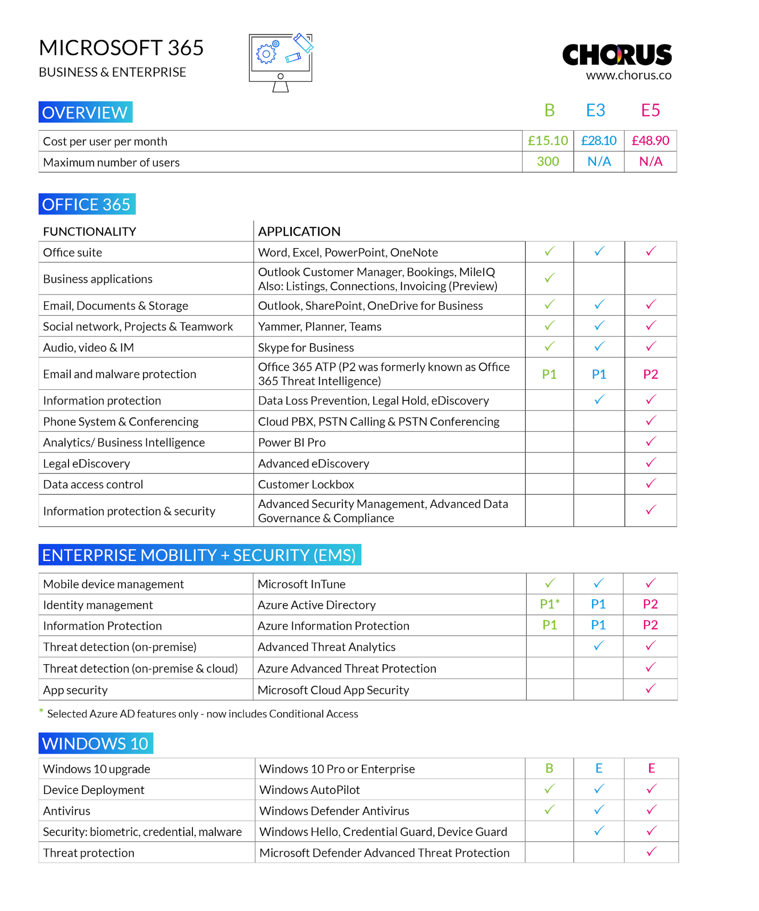

1. 43. Question

This question requires that you evaluate the underlined text to determine if it is correct.

When planning to migrate a public website to Azure, you must plan to pay monthly usage costs.

Instructions: Review the underlined text. If it makes the statement correct, select “No change is needed”. If the statement is incorrect, select the answer choice that makes the statement correct.

* +  pay to transfer all the website data to Azure
  +  No change is needed
  +  reduce the number of connections to the website
  +  Deploy a VPN

Unattempted

In Azure, you only pay for outbound traffic which is charged in GB as you are entitled to 5GB in a month but afterward you pay for data being transferred out. However, with inbound data traffic into your environment, this is free.

1. 44. Question

You are an IT administrator for ABC company. You have been advised to identify important factors while performing a Cost-benefit analysis while deciding on a cloud solution. Please identify 4 of them.

* +  Improved security
  +  Reduced security
  +  Improved availability
  +  Reduced TCO
  +  Increased TCO
  +  Increased end-user productivity

Unattempted

<https://subscription.packtpub.com/book/cloud_and_networking/9781838982171/14/ch14lvl1sec86/cost-benefit-analysis-for-on-premises-versus-the-cloud>

1. 45. Question

The Service Desk Team in your company has indicated that they spend a lot of time helping users reset their passwords as they keep forgetting them. In order to improve the productivity of your Service Desk Team which feature can you implement as a Global Administrator.

* +  Self-Service password reset(SSPR)
  +  Identity protection
  +  Customer banned password list
  +  Multi-factor authentication

Unattempted

Self -service password reset (SSPR) feature allows user to reset their passwords from anywhere through internet browser.  
Self-Service Password Reset (SSPR) is an Azure Active Directory (AD) feature that enables users to reset their passwords without contacting IT staff for help. The users can quickly unblock themselves and continue working no matter where they are or time of day. By allowing the employees to unblock themselves, your organization can reduce the non-productive time and high support costs for most common password-related issues.  
More information:  
<https://docs.microsoft.com/en-us/azure/active-directory/authentication/howto-sspr-deployment>

1. 46. Question

Tenant isolation refers to which of the following concepts?

* +  Separation of organizational data in a single-tenant environment
  +  Separation of organizational data in a multi-tenant environment
  +  Securing records storage in the third party system
  +  ISO compliance

Unattempted

One of the primary benefits of cloud computing is the concept of a shared, common infrastructure across numerous customers simultaneously, leading to economies of scale. This concept is called multi-tenancy. Tenant isolation here refers to the separation of organizational data in a multi-tenant environment.

1. 47. Question

Microsoft Cloud App Discovery can be used to do which of the following?

* +  Report on the application compatibility
  +  Find new applications compatible with Office 365
  +  Provide cloud applications to Windows 10 devices
  +  Identify " Shadow IT"

Unattempted

“Shadow IT” refers to applications being used without the consent of the organization. Security teams often need to understand what applications are being used in business and it is when they actually discover such applications.  
With Microsoft Cloud App Discovery, administrators can import firewalls and proxy logs that help them in which apps are being used when these logs are analyzed for traffic.

1. 48. Question

Your company hosts an accounting named App1 that is used by all the customers of the company.

App1 has low usage during the first three weeks of each month and very high usage during the last week of each month.

Which benefit of Azure Cloud Services supports cost management for this type of usage pattern?

* +  load balancing
  +  high availability
  +  elasticity
  +  high latency

Unattempted

Elastic computing is the ability to quickly expand or decrease computer processing, memory, and storage resources to meet changing demands without worrying about capacity planning and engineering for peak usage. Typically controlled by system monitoring tools, elastic computing matches the number of resources allocated to the number of resources actually needed without disrupting operations. With cloud elasticity, a company avoids paying for unused capacity or idle resources and doesnt have to worry about investing in the purchase or maintenance of additional resources and equipment.

<https://azure.microsoft.com/en-us/overview/what-is-elastic-computing/>

1. 49. Question

Compliance Manager has a number of templates, prepopulated with the controls which are managed by both the customer and Microsoft. Does the Compliance Manager allow customers to import custom templates?

* +  No
  +  yes

Unattempted

Microsoft Compliance Manager (preview) is a free workflow-based risk assessment tool in the Microsoft Service Trust Portal for managing regulatory compliance activities related to Microsoft cloud services. Part of your Microsoft 365, Office 365, or Azure Active Directory subscription, Compliance Manager helps you manage regulatory compliance within the shared responsibility model for Microsoft cloud services.  
Microsoft Compliance Manager does allow for importing custom templates as shown in the below picture

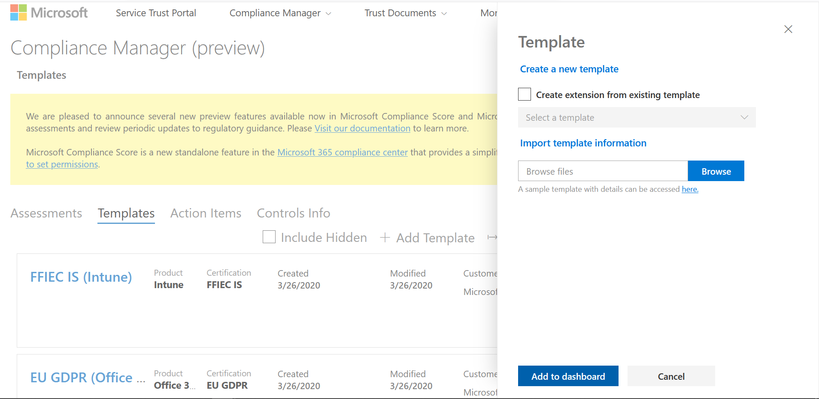

1. 50. Question

Identify three of the encryption technologies or platforms used to secure data in Microsoft 365 from the following:

* +  Bootstrapper
  +  Bitlocker
  +  Internet Protocol Security (IPSec)
  +  Transport Layer Security
  +  Encryption Manager

Unattempted

The encryption process encodes your data (referred to as plaintext) into ciphertext. Unlike plaintext, ciphertext can’t be used by people or computers unless and until the ciphertext is decrypted. Decryption requires an encryption key that only authorized users to have. Encryption helps ensure that only authorized recipients can decrypt your content. Content includes files, email messages, calendar entries, and so on.  
With Office 365, your data is encrypted at rest and in transit, using several strong encryption protocols, and technologies that include Bitlocker, Transport Layer Security/Secure Sockets Layer (TLS/SSL), Internet Protocol Security (IPSec), and Advanced Encryption Standard (AES).

1. 51. Question

When opening a service ticket, which severity level is used to indicate a significant loss or degradation of services, requiring immediate attention?

* +  Severity C
  +  Severity D
  +  Severity B
  +  Severity A

Unattempted

<https://docs.microsoft.com/en-us/office365/servicedescriptions/office-365-platform-service-description/support>

1. 52. Question

You have an on-premises network that contains 100 servers.

You need to recommend a solution that provides additional resources to your users. The solution must minimize capital and operational expenditure costs.

What should you include in the recommendation?

* +  complete migration to the public cloud
  +  a private cloud
  +  an additional data center
  +  a hybrid cloud

Unattempted

Private Cloud is indeed the correct answer, and here is why: The on-premise solution that they already have can already be seen as a private cloud. The most cost-effective way is indeed to add a public cloud to their current network. Now the real question is in the last sentence “What should you include in the recommendation?”. Even if you want to recommend a hybrid cloud, which would minimize CapEx and OpEx, a hybrid cloud is made up of both public- and a private

1. 53. Question

Compliance Manager contains built-in templates for which three standards?

* +  GDPR
  +  PCI-DSS
  +  NIST 800-53
  +  NIST CSF

Unattempted

1. 54. Question

You are an IT, administrator, for a commercial organization with more than 15000 employees. Which Microsoft 365 product service family is the best option for your organization?

* +  Microsoft 365 Business
  +  Microsoft 365 Education
  +  Microsoft 365 GCC
  +  Microsoft 365 commercial

Unattempted



1. 55. Question

You plan to migrate a web application to Azure. The web application is accessed by external users.

You need to recommend a cloud deployment solution to minimize the amount of administrative effort used to manage the web application.

What should you include in the recommendation?

* +    database as a service (DaaS)
  +  platform as a service (PaaS)
  +  software as a service (SaaS)
  +    infrastructure as a service (IaaS)

Unattempted

It is a custom web app deployed to Azure the answers is PasS. If it was a Microsoft product, then it could be a SaaS. Otherwise, your own apps deployed into the cloud run on PaaS ( they just provide the environment, “platform”)

1. 56. Question

Which cloud deployment solution is used for Azure virtual machines and Azure SQL databases? To answer, select the appropriate options in the answer area(Select Two).

* +  Azure SQL databases: Platform as a service (PaaS).
  +  Azure SQL databases: Infrastructure as a service (IaaS).
  +  Azure virtual machines: Infrastructure as a service (IaaS).
  +  Azure virtual machines: Platform as a service (PaaS).

Unattempted

Azure SQL Database is a relational database-as-a-service (DBaaS) hosted in Azure that falls into the industry category of Platform-as-a-Service (PaaS).  
Microsoft recently announced the release of Windows Azure Virtual Machines, an Infrastructure-as-a-Service (IaaS) offering in Windows Azure.

1. 57. Question

Identify four licensing models which can be used to acquire Microsoft 365 services

* +  CSP
  +  Commercial
  +  EA
  +  Microsoft Open
  +  Service Provider License Agreement

Unattempted

The Cloud Solution Provider(CS) program helps you go beyond reselling licenses to being more involved in your customers’ businesses.  
The Microsoft Enterprise Agreement offers the best value to organizations with 500 or more users or devices that want a manageable volume licensing program that gives them the flexibility to buy cloud services and software licenses under one agreement.  
Microsoft Open programs, Open Value, and Open License are a simple, cost-effective way for small and midsize organizations to acquire the latest Microsoft technology.  
The Microsoft Services Provider License Agreement (SPLA) is for service providers and independent software vendors (ISVs) who want to license the latest eligible Microsoft software products to provide software services and hosted applications to end customers.

1. 58. Question

Data Residency answers which of the following questions?

* +  What encryption is used to protect my data?
  +  Who has access to my data?
  +  Which security standards are applied to my data?
  +  Where is my data stored?

Unattempted

Data residency is related to where geographically your data is located.  
Data residency option :  
With this option, customers with data residency requirements can request early migration of their organization’s core customer data at rest to their new datacenter geo

1. 59. Question

Which of these is not a way to view service status updates for Microsoft 365?

* +  Service Health Dashboard
  +  Security and compliance center
  +  Service Status page
  +  Twitter

Unattempted

How to check service health  
1)Go to the Microsoft 365 admin center at https://admin.microsoft.com, and sign in with an admin account. To view service health, in the admin center, go to Health > Service health, or select the Service health card on the Home dashboard. The dashboard card indicates whether there is an active service issue and links to the detailed service health page.  
2)For Microsoft 365 updates on Twitter, please follow @MSFT365Status.  
3)If there are issues preventing you from signing in to your Office 365 service health dashboard. View your Microsoft 365 Service health on status.office365.com.

1. 60. Question

Which Microsoft 365 tool can organizations use to track their progress against industry compliance standards?

* +  Compliance Dashboard
  +  GDPR Accelerator
  +  Compliance Manager
  +  Compliance Accelerator

Unattempted

What is Compliance Manager  
Microsoft Compliance Manager (preview) is a free workflow-based risk assessment tool in the Microsoft Service Trust Portal for managing regulatory compliance activities related to Microsoft cloud services. Part of your Microsoft 365, Office 365, or Azure Active Directory subscription, Compliance Manager helps you manage regulatory compliance within the shared responsibility model for Microsoft cloud services.  
More Information:  
<https://docs.microsoft.com/en-us/microsoft-365/compliance/compliance-manager-overview?view=o365-worldwide>